Setup REDHAT Cluster Suit in RHEL/CentOS 5.x

Configuration Part is so simple, if you understood the Each Component concept of Cluster, if not then it will complex.
So please you must have patience and read and understand it.

What is it clustering?

At its most basic meaning, a "Cluster" is nothing more than two or more computers working together to accomplish a common task. Beyond that, a "cluster" can be anything the implementer designs it to be.

Why Clustering?

Every Technology is Solution to the particular problem, so there is different cluster for every problem. There are two main problems that clusters try to resolve Performance and High Availability.
1) Performance clustering use for increase performance for application. Example LVS (Linux Virtual Servers).
2) High Availability Cluster will provide shared file systems and will provide for the high availability. We will do HA (it's not heartbeat don't get confuse). We will setup on Virtual Server in VMware.

Basic Overview on High Availability Cluster:

It has two main components:
- CMAN (Cluster Manager)
- Resource manager.
The cluster itself is responsible for maintaining the cluster nodes in a group. This Group is part of a "Close Process Group" (CPG). When node fails, the CMAN must detect the failure, reliably eject the node from cluster using fencing and then reform the CPG. Each time the cluster changes (re-forms), the resource manager is called. The manager checks to see how the cluster changed, consult configuration and determines what to do, if anything.

Let's see components:
CMAN

It acts mainly as a quorum provider. That is, is an ad up the votes from cluster members and decides if there is a simple majority, if there is the cluster quorate and is allowed to provide cluster services. If you start only CMAN, then it will just form cluster, it will not start any services, we have to start rgmanager (resource manager) for starting and manage services.

OpenAIS

Which provided totem, it’s a Heart of the Cluster and Based of Service Availability Forum Application interface specification. AIS is an open API designed to provide interoperable high availability services. Almost all other cluster component operates through this. OpenAIS sends messages using multicast, it manage membership. Its goals are to mask not just hardware failures, but also application-level faults.
But note that it has been removed in RHEL 6 Cluster version 3. Because it overkill the cluster, Basically it's divided into two Parts Half required part has been moved to API called corosync (which will provide only totem, multicast messaging, Basic API ) and Full API is OpenAIS. so in REDHAT 6 there is corosync instead of openAIS. So don't start/stop openais service. It will manage by CMAN. If you start before CMAN, then you will face too many issues.

To read more about OpenAIS check this Page.

Quorum
Quorum is defined as the minimum set of hosts required in order to provide cluster services and is used to prevent split brain situations. Quorum algorithm used by RHCS is called "Simple Majority Quorum" which means more than half of hosts must be on-line and communicating in order to provide services. It’s common simple algorithm, there is other
quorum algorithm exists example "Grid quorum", "YKD Dynamic Linear Voting” etc..
The Idea behind quorum is that when a cluster split into two or more partitions, whichever group of machine has quorum can safely start cluster services knowing that no other lost machines will try to do same.
Let’s take Scenario:
Suppose you have Cluster of 4 Nodes, each with 1 Vote.
The Cluster Expected votes are 4 and Cluster Majority in this case is 3.
Because (4/2) + 1, rounded down is 3
- Now imagine that there is failure in Network and one of the node disconnects from the rest of cluster.
- Now you have two Partitions
1) One partition contains 3 nodes
2) Other Partition has 1 node
- So first partition has quorum and other node will lose the quorum.
- The first partition with quorum will reconfigure and continue to provide cluster service
The partition without quorum will remove from the cluster and shut-down all cluster services on it.
That is Basic but what exactly happen is when one node lost the quorum then first cluster will try to remove that node from cluster using fencing. Once the fencing has been confirmed successful then cluster re-form with 3 nodes and continue to provide cluster services.
This also helps explain why an even 50% is not enough to have quorum, a common question for people new to clustering. Using the above scenario imagine if the split were 2 nodes, because either can't be sure what the other would do, neither can safely proceed. If we allowed an even 50% to quorum, both partitions might try to take over the cluster services.
Even in a two-nodes cluster through proper quorum can be maintained by using a quorum disk called "QDisk".

Fence
Why?
Fencing is just used for remove hung, dead node from cluster. There are many facing available based on your server class hardware.
What is?
In clustering, fence refers to the action of removing a node from the cluster.
How it work?
A fence is carried out when the cluster software determines a node is faulty. Once this decision is made, the cluster software consults it's configuration for information on how to carry out the fence. The fence action is in turn carried out by a software or hardware action. The details of which depend on the fence method(s) configured for the node being fenced. Multiple nodes may be fenced at a time, if necessary. Red Hat Cluster Suite provides a variety of fencing methods:
• Power fencing — a fencing method that uses a power controller to power offs an inoperable node. Two types of power fencing are available: external and integrated. External power fencing powers off a node via a power controller (for example an API or a WTI power controller) that is external to the node. Integrated power fencing powers off a node via a power controller (for example,IBM Bladecenters, PAP, DRAC/MC, HP ILO, IPMI, or IBM RSAII) that is integrated with the node.
• SCSI3 Persistent Reservation Fencing — a fencing method that uses SCSI3 persistent reservations to disallow access to shared storage. When fencing a node with this fencing method, the node's access to storage is revoked by removing its registrations from the shared storage.
• Fibre Channel switch fencing — A fencing method that disables the Fibre Channel port that connects storage to an inoperable node
• GNBD fencing — A fencing method that disables an inoperable node's access to a GNBD server
We will be using manual fencing, because it helps us to understand the flow, after manual fencing you can use VMware fencing. More information can be found below:
Red Hat's Fencing Wiki

Rgmanager
rgmanager is the Resource Group (Service) Manager. It controls starting, stopping, migrating, relocating and recovering services within the cluster. It manages and provides failover capabilities for collections of resources called services, resource groups, or resource trees in a cluster
More information can be found below:
Red Hat's RGManager Wiki

QDisk
Why?
Its use for avoid split-brain situation in Cluster.
What is?
A Quorum disk, known as a qdisk is small partition on SAN storage used to enhance quorum. It generally carries enough votes to allow even a single node to take quorum during a cluster partition. It does this by using configured heuristics that is custom tests, to decide which node or partition is best suited for providing clustered services during a cluster reconfiguration. These heuristics can be simple, like testing which partition has access to a given router, or they can be as complex as the administrator wishes using custom scripts. We will define heuristics ping to gateway.
How it work?
The way a qdisk works, at its most basic, is to have one or more votes in quorum. Generally, but not necessarily always, the qdisk device has one vote less than the total number of nodes (N-1). In a two node cluster, the qdisk would have one vote. In a seven node cluster, the qdisk would have six votes.
More information can be found below:
Red Hat's QDisk Wiki

Totem
The totem protocol defines message passing within the cluster and it is used by openais. A token is passed around all the nodes in the cluster, and the token timeout is defined in fencing. The counter, then, is the number of lost tokens that are allowed before a node is considered dead. The totem protocol supports something called 'rrp', Redundant Ring Protocol. Through rrp, you can add a second backup ring on a separate network to take over in the event of a failure in the first ring. In RHCS, these rings are known as "ring 0" and "ring 1".

Cluster Management tool

There are tree tools in RHEL 5 to manage Cluster

Conga

In Conga, you will manage your cluster through web Interface and there are two tools in conga lucci and ricci.

Ricci is agent service which will be installed in all member of the cluster and lucci will be installed in any one member of cluster.

system-config-cluster

Its Graphical tool, you need to run from Run level 5. Using system-config-cluster command

ccs_tool

Its command line tool, you can configure using this tool.

All Management tool at the last configure and updating the cluster.conf file, its xml file.



Our Setup

VMware Workstation 8

Two Centos 5.7 Nodes and 1 Storage Open filer
Interface |  | IP Address | Host Name(s)
Internet/Bridge | eth0 | 10.0.0.11 | nod1.altnix.com
Host only | eth1 | 192.168.0.11 | nod1.altnix.com
Internet/Bridge | eth0 | 10.0.0.12 | nod2.altnix.com
Host only | eth1 | 192.168.0.12 | nod2.altnix.com
Host only | eth0 | 10.0.0.13 | storage.altnix.com
Host only | eth1 | 10.0.0.14 | storage.altnix.com

While installing do customize installation and remove unwanted packages like Office tools, Sounds/Video, Games and Bluetooth etc. Our setup would be like following 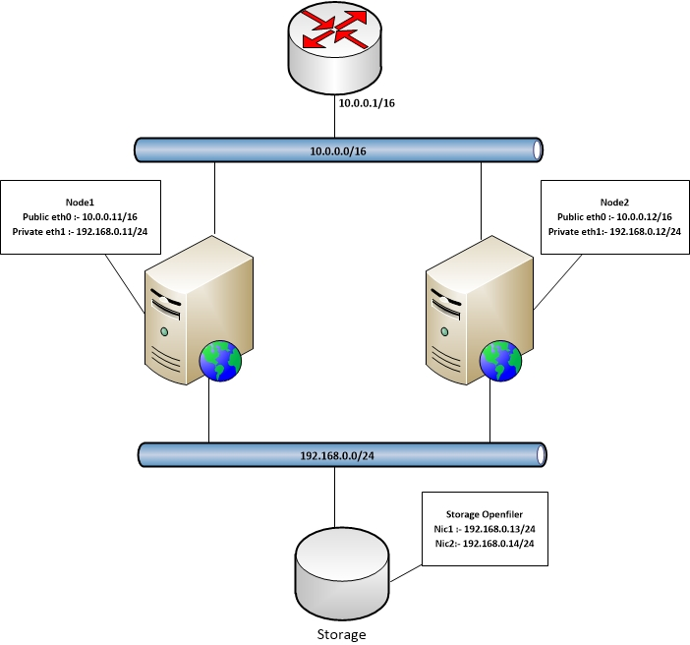

Each node communicates each other using private IP address i.e. 192.168.0.0/24 and Floating/Virtual IP i.e. 10.0.0.100/16 accessible from network

